Blog 41: What is the job of the Holy Spirit in our life?

God sent Israel a cloud to guide the Israeli Nation to the promised land. It is my take that the cloud was the Holy Spirit. Not all my compadres agree with me on this. I have no scriptural -verse reason for this position, but it appears to me as work of the Holy Spirit.

At the time of the crossing Israel had been under the rule of Egypt for over 400 years and were slaves at the time.
The Cloud
Exo_40:36 And when the cloud was taken up from over the tabernacle, the sons of Israel journeyed on in all their journeys.
Exo_40:37 But if the cloud was not taken up, then they did not journey until the day that it was taken up.
______________________________________________
In the same way the Holy Spirit guides you today. To stay within the will of God, we must listen to and follow the Holy Spirit.

___________________________________________________

Interestingly, the Holy Spirit took Israel the long way to Kadesh Barnea. If Israel had gone East only it would have saved approximately 450 miles. (See map below)
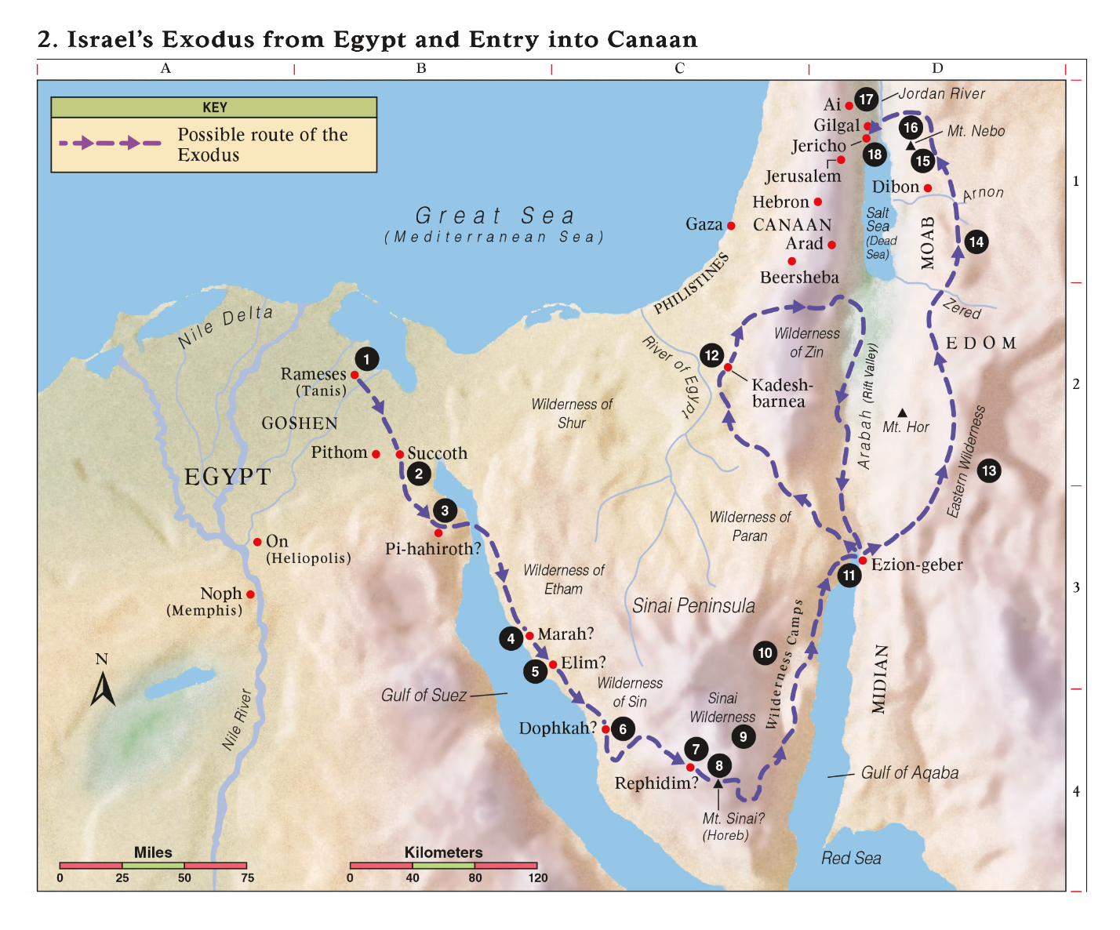
Why didn’t the cloud lead them on this the shorter route?
____________________________________________________
Israel was moving on a 400-year-old promise to a man named Abraham. This promise had been passed through stories all the years.

If they had entered “the promised land” 2 years into the start of the journey at Kadesh Barnea, they probably would have had little resistance. Entering at Jericho 40 years later matched them with large fortified cities. Why did God do this? Of course, I don’t know but I think it was to give Israel trials and suffering to mature the people and toughen up the nation.
Jesus learned obedience through suffering and so do we and so did they.

__________________________________________________

On all Con and my moves, I must say that God has always been very good to us and sent a “cloud” to help us find our way.

One thing this move has burned into me is the faithfulness of God to watch out for us and we should be grateful for His love and sovereignty. We need to practice our gratefulness, always.
___________________________________________________

The "Holy Spirit" is a phrase in the Bible used to describe the mystery and power of God's personal presence.

As Joel prophesied, the “new thing” now available to both men and women is the Holy Spirit. He was promised by God’s new covenant people after the death, resurrection, and ascension of Christ.”
____________________________________________________
From the gospel of John, we hear Jesus promise, “And I will ask the Father, and he will give you another advocate to help you and be with you forever—the Spirit of truth. The world cannot accept him, because it neither sees him nor knows him. But you know him, for he lives with you and will be in you” (John 14:16–17).
Advocate means
An intercessor, consoler: - advocate, comforter a person who pleads on behalf of another; intercessor. ____________________________________________________
What is the job of the Holy Spirit in our life?
Spiritual gifts or power is given to us by the Holy Spirit. These are the supernatural graces which individual Christians need to fulfill the mission of the Church. The Holy Spirit in us is to bear fruit.
____________________________________________________
Below is a list of job assignments to the Holy Spirit. The ones with “~” mark the ones I have known and experienced. Score yourself.
What is the job of the holy Spirit?
1. “But the Comforter, the Holy Spirit, whom the Father will send in My name, He shall teach you all things and bring all things to your remembrance, whatever I have said to you.” (John 14:26).
2. He indwells believers and seals them until the day of redemption. He indwells (Ephesians 1:13; 4:30). ~
3. The Holy Spirit assists believers in prayer (Jude 1:20) and “intercedes for God’s people in accordance with the will of God” (Romans 8:26–27). ~
4. The Holy Spirit regenerates and renews the believer (Titus 3:5).
The Spirit baptizes the believer into the Body of Christ (Romans 6:3). ~
5. Believers receive the new birth by the power of the Spirit (John 3:5–8). New creation. ~
6. Rom 15:13 And may the God of hope fill you with all joy and peace in believing, that you may abound in hope through the power of the Holy Spirit. The Spirit fills believers causing believers to “overflow with hope” ~
7. Sanctification is a work of the Holy Spirit in the life of a believer. Sanctification is manifested in our obedience to the Word. The Spirit sets Himself against the desires of the flesh and leads the believer into righteousness (Galatians 5:16–18). ~
8. The works of the flesh become less evident, and the fruit of the Spirit becomes more evident (Galatians 5:19–26).
Fruit of the spirit: Gal 5:22 But the fruit of the Spirit is “love,
joy, peace, long-suffering, kindness, goodness, faith,
meekness, self-control; against such things there is no law”. ~ Gal 5:23
9. Believers are to “be filled with the Spirit” (Ephesians 5:18), i.e. they are to yield themselves to the Spirit’s full control.
10. The Holy Spirit is also a gift-giver. “There are different kinds of gifts, but the same Spirit distributes them” (1 Corinthians 12:4). ~
What is your giftedness?
11. Jesus promised that He would send the Holy Spirit to “convict the world concerning sin and righteousness and judgment” among unbelievers (John 16:8, ESV).
12. The Spirit testifies of Christ (John 15:26), pointing people to the Lord. ~
13. Currently, the Holy Spirit is also restraining sin and combatting “the secret power of lawlessness” in the world. (2 Thessalonians 2:6–10).
14. “The Spirit searches everything, even the depths of God. For who knows a person’s thoughts except the spirit of that person, which is in him? So also no one comprehends the thoughts of God except by the Spirit of God” (1 Corinthians 2:10–11). ~
15. With the Spirit, we can comprehend the thoughts of God, as revealed in the Scripture. We can understand the bible. (1 Corinthians 2:12–13). ~
Joh_20:22 And when He had said this, He breathed on them and said to them, “Receive the Holy Spirit”.
____________________________________________________

The Gifts and where they are:
Romans 12
exhortation
giving
leadership
mercy
prophecy
service
teaching

1 Corinthians 12
administration
apostle
discernment
faith
healings
helps
knowledge
miracles
prophecy
teaching
tongues
tongues interpretation
wisdom

Misc. Passages
celibacy
hospitality
martyrdom
missionary
voluntary poverty
Ephesians 4
apostle
evangelism
pastor
prophecy
teaching

Application:
- Evaluate and think on the works of the Spirit in your life.
- Note the ones you have experienced.
- Note the ones that you are not sensing and ask God to show them to you.
- Go for the fruit of the Spirit.

